Meta Description:
This Guide covers every aspect related to Local SEO. From what is it to how to do it effectively, be a pro Local SEO expert by reading this guide.

Expert Guide on Local SEO: What Is It & How to Do It Effectively
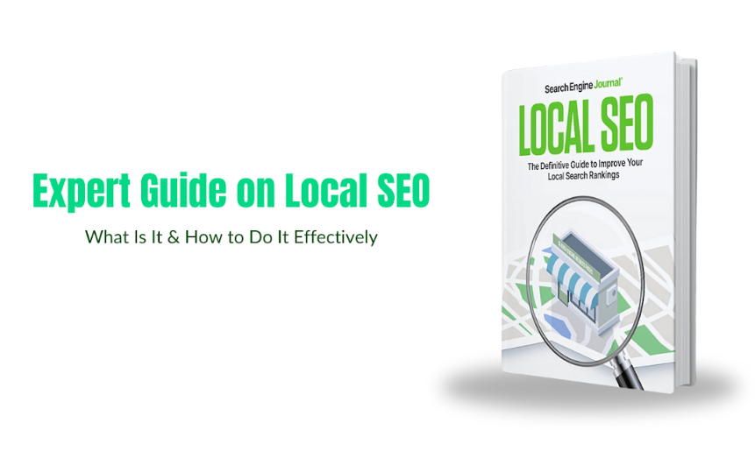
Due to the ever-growing importance of the internet in the world economy, more and more companies are beginning to rely on the internet to market their products.
In the internet or digital marketing, no one can deny the role of local SEO in the building of brand reputation and generating more sales.
In this blog, we will explain the fundamentals of Local SEO, why it is crucial, and how the procedure can be employed efficiently.

What Is Local SEO?
Local SEO is the process of optimizing factors such as the website, social media profiles and online business listing to help rank higher in local queries. This practice aims at using the right location-based keywords and puts your business information as right and as uniform as possible.
Local SEO strategies will make sure that your business can be found by consumers targeting particular geographical locations through search engines such as Google. So, Local SEO in Dubai is or any other particular market is inevitable for the success of any business.

Importance of Local SEO for Businesses:
Local SEO is not an advantage, but a necessity for every business that is looking to get to the top of their local market. As more and more people start to locate their local service and products via search engines, companies that do not appear in local search results could lose significant revenues.
Local SEO is an effective technique that is useful in increasing traffic in business premises, improving customer interaction, and even making a business popular in a certain region.

Targeting Location-Specific Search Queries:
It is one of the major trends of Local SEO to target search phrases based on specific location. For instance, to find the best digital marketing company near me in Dubai or any other part of the world, you have to filter through various local results that could include your business. Therefore, the usage of locationally sensitive keywords along with Meta description can help you to target local people and to be noticed when you type in a certain location.

Differences Between Local SEO and Traditional SEO:
Both Local SEO and traditional SEO work on improving the ranking of a website or specific pages of the site in search results. Traditional SEO is less specific, or rather, it can have a global focus, while Local SEO is more pointing to a definite region. Local SEO takes extra measures like keywords targeting the particular local areas, and the use of local directories for a business, like Google My Business.

Why Is Local SEO Essential?
Curious why Local SEO should be the top priority of your business? Let’s put an end to your curiosity by explaining why local SEO is so significant for your business.
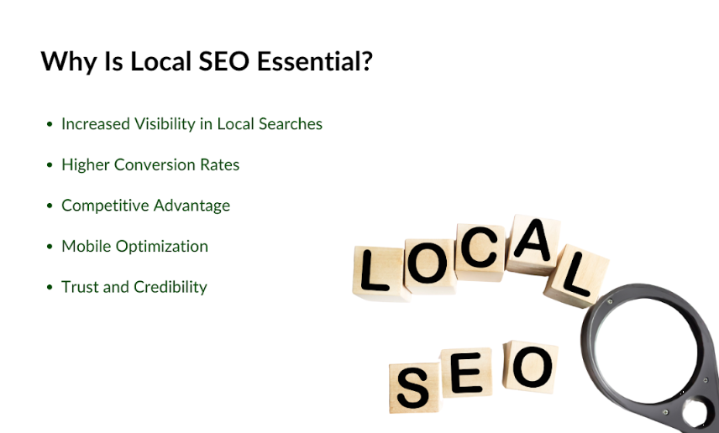

Increased Visibility in Local Searches:
Local SEO improves the chances of your business appearing on local searches, which will go a long way in helping you sell your products or services to those searching for them online. This is important for increasing the number of the customer base and acquiring more clients through sales generation.

Higher Conversion Rates:
In most cases, local searches are a sign of purchase intent. Whenever customers are making searches by their location, they are in the process of whether to make a purchase or not. It will provide high conversion as you get specific targeted users willing to engage your business as compared to organic traffic.

Competitive Advantage:
A local business must master local SEO as this will enable them to compete with other businesses in the same locality. Integrated local SEO marketing strategy means your business is listed ahead of the other businesses with the same products or services.

Mobile Optimization:
Mobile searches have become more common in the current society with the use of smartphones. Some of these searches are local from the users who are actively searching your services or products that your business offers. To capture that particular audience for your site, you need to ensure that your website is mobile-friendly.

Trust and Credibility:
Trust and credibility are two major factors that can differentiate your business from your competitors. Through this, you can ensure that all the information that you post to the various mediums provides a feeling to customers that you are a genuine business. By connecting with the local audiences through content and social media platforms, it helps you enhance this level of trust effectively.

Improved Online Reputation:
Local SEO also involves the handling of online comments from the customers as a review for your products and services. It is well understood that positive feedback can help in improving the reputation of your business and in persuading other people to visit your business. Satisfied customers should be encouraged to post recommendations for your business while complaints of dissatisfied customers should be addressed immediately as a part of Local SEO.

How Exactly Local SEO Functions?
It is very important to understand how exactly Local SEO works to take advantage of it. Let’s have a look at different factors to understand the exact working process of Local SEO:

Proper Understanding of Local Searcher Intent:
General searches are usually broader and don’t necessarily have to be done by a searcher within a particular locality. On the contrary, local search is focused and carried out within a specific location. For instance, when you type “Digital Marketing near me” or “Digital Marketing Agency near me”, you will see at the top of search results all agencies that offer what you are looking for. Local SEO strives to meet this intent through making your business available for the mentioned searches.

How Local Search Queries Differ from General Searches?
Local searches or local keywords contain location references and are mostly designed to depict an action. While the general search may be broader or superficial, the local search is usually targeted. This is because they are in a good position to identify and understand such differences that can help in formulating the right SEO strategies to meet the needs of your business.

Local Algorithm Factors:
To appear at the top of the local search, there is a need for the essential factors that affect the algorithms that rank local searches. To establish relevancy as well as the business’s authority in the particular field of specialization for the local search query, Google takes into consideration the following factors to determine the relevance:

- Locus: Refers to your business’s relevance depending on the location of the searcher or the location the search was initiated from.
- Relevance: The match between the search query and your business offerings.
- Authority: Your business's online reputation and presence.

Key Factors Google Considers in Local Search Ranking:

- Google My Business (GMB) Optimization: A GMB profile that has been optimized to the maximum can be termed as ideal. For your benefit, make sure that the business name, address and phone number (NAP) contain the same data.
- Positive Reviews: Reviews on the search engines such as Google Maps, Yelp, and TripAdvisor must lead to a higher ranking.
- On-Page SEO: The keywords, meta descriptions and content used in the website should reflect local searches about certain locations.
- Local Citations: While listing your business on the directories, they should be very honest and should not deviate from the original information about the business.

On-page SEO Techniques:
Local ranking cannot be effective if there is no proper optimization of on-page SEO. It is a process of enhancing several on-site factors that can increase your website’s ranking in the local search.

Importance of On-Page Optimization for Local Ranking:
Local Search Engine Optimization helps to make your website easily indexable by the search engine and usable for local search. This involves using local keywords on the title tags, meta descriptions, headings, and the content of the concerned sites.

Keyword Research for Local SEO:
In any SEO campaign, the right keywords are the most important aspects that need to be found and incorporated into the strategy. When it comes to keywords, as regards a local market, try to include a keyword choice that potential consumers would possibly use when searching for your business.

How to Identify Relevant Keywords and Phrases?
Beginning with compiling a list of all the keywords that characterize your business and the type of services provided. Some of the tools that are effective for researching possible keywords and their aspects include Google’s Keyword Planner for issues such as search volume and difficulty scores.
One of the tools that can be used for this purpose is Google’s Keyword Planner. For local SEO, Keyword Planner of Google is an effective tool. It helps to trace the frequency of the defined keywords, level of competition and the fluctuations of the same, which are important in strategy development based on the keywords.

Long-Tail Keywords for Local SEO:
Long-tail keywords are specific than general keywords as they are less competitive in the market. Such keywords are quite relevant to the needs of the target audience, which is searching for services of a local nature.

Benefits of Targeting Long-Tail Keywords:
- Higher Conversion Rates: People who use plural keywords are usually closer to making the purchase when compared to those individuals who type broad terms.
- Fewer rivals: Most of these keywords attract lesser competition by the rival websites or webpages and rank higher easily.
- Increased Relevance: They give better association of your products with the users’ search strings.

Link-Building Strategies in Local SEO:
Even today it is obligatory to pay attention to link building as an element of SEO strategy. In the local context, it entails getting links from other local sites and directories to increase the status of your site.

Effective Link-Building for Improved Local Search Visibility:
- Local Directories: It is crucial to register your business in directories to ensure it is easily spotted comprehensively.
- Link Building: Engage the locals through affiliate marketing and social activities to get local links.
- Local Media: Gain visibility by being associated with local press or articles from local newspapers, magazines, blogs, etc.

Implementing Effective Local SEO Strategies:
In the contemporary business environment, the visibility of a business is very important to reach out to customers and ensure that the business is growing. Local SEO has emerged as an essential plan for any business to target local audience effectively. Have a look at the major factors to implement local SEO strategies:

Conduct Keyword Research for Local SEO:
Keyword research is that fundamental basis on which one can build an efficient and effective local SEO marketing strategy. The purpose is to find out the keywords that your prospective local customers may be using. Here are the best practices for finding the right local keywords:
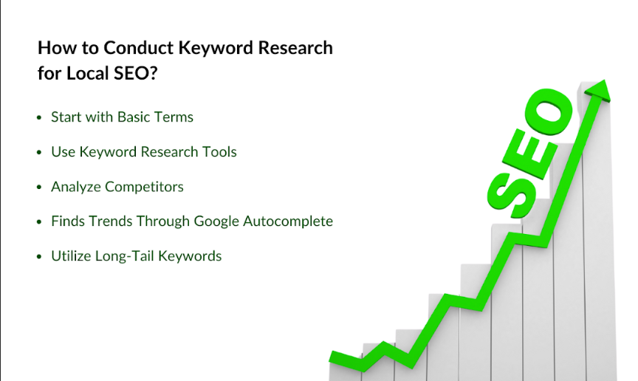
- Start with Basic Terms: The process of developing keyword ideas can be started by producing simple descriptors that in one way or another are related to your business, industry or the goods and services that you are offering. Ensure that you include your business location in these terms.
- Use Keyword Research Tools: Many tools enable you to find out the volumes of local searches and related terms such as Google Keyword Planner.
- Analyze Competitors: It is also necessary to see which keywords your competitors are targeting in the local search. This may indicate which keywords may be effective to be targeted on.
- Finds Trends Through Google Autocomplete: This can be used in uncovering some of the local trends people are searching on the internet, as well as the questions they want answered in their local regions.
- Utilize Long-Tail Keywords: These are less popular keywords that the intended customer may type into the search engine, for instance, ‘Beat digital marketing agency near me’ or ‘digital marketing services near me in Dubai’.

Optimize Your Website for Local Terms:
Once you are done with your local keywords, the next thing which you should do is to optimize your site for these keywords:

- Title Tags & Meta Descriptions: Specify your local keyword and geographic location of your business in metas. For example, “Affordable Digital Marketing Agency in Dubai | TAM.”
- Leverage Your Local SEO: In case you operate in several areas, it is advantageous to develop localized pages. This in turn serves the purpose of enhancing the results from location-based search engine optimizations.
- Local Schema Markup: Schema markup is the tagging that can aid the search engines to determine the physical location and any other attribute of your business.
- Use Local Keywords within Content: The use of the local keywords should be employed naturally throughout the content as well as in the headers and subheaders. This should always focus on appropriateness based on the location of the target audience.
- Add Local Business Information: The NAP should be incorporated in your site, preferably on every page, to match the information listed in your business listings.

Google Business Profile Optimization:
A Google Business Profile is essential for local SEO. GMB can help your business be displayed in local queries, Maps, and the Local Pack. Here are ways on how to start implementing it and how to use it to its full potential:

- Must Have GMB Profile: Ensure that your business is on Google My Business and that it is verified.
- Good user information: Complete Your Profile and ensure to provide detailed information. For example, you can provide information about your business operating schedule and types of services you offer as well as uploading an image.
- Brand Awareness: Incorporate your business keywords in your description and the posts on the social network.
- Invite feedback: Always invite feedback from buyers, who are happy with their purchase and also ensure that you give a quick response.

Create Localized Content:
Local content acts as the outreach that residents can relate with and ensure you are meeting their needs.
- Report News in Your Region: Describe the occurrences happening within your locality and how your enterprise comes in or would be useful to the participants.
- Promote Stories of Success: Getting success stories and testimonials of local users can be an ideal way to promote a product.
- Blog Posts: Provide local information or items of local interest and write their material in a way that at least 75% of it will contain local keywords.
- Be active on social media: To engage with the target demographic, use local influencers to devise content that would appeal to the local population.

Harness Social Media for Local Engagement:
Social networking is one of the significant avenues commonly used in local communication. Here is how you can harness the social media for local engagement:

- Amplify Geo Targeting: Employ geographical targeting in your Social Media Advertisement to reach out to a specific region.
- Connect with the Communities: Use social media sites such as Facebook and LinkedIn to join a local group or forum.
- Mention Funds: Your informational content should mention funds available from business to other businesses or even to the public.
- Inspire Customer Pictures and Stories: Customers should be encouraged to upload photos concerning your business and especially on the organization’s social media pages.

Build Local Citations:
Backlinks or any kind of reference that your business gets on other websites help in local SEO. Consistency is key to build local citation through methods like:
- Check Consistency of NAP: Business name, address, and phone number (NAP) must be the same, and the same details must be used throughout the online directories.
- Citation Management and Verification: The citation management and local citations can be done by the usage of such tools as Moz local.
- Locally: Place your business in all local directories and possible online platforms related to your field.
- Periodically Review: Ensure there are no incorrect citation records and that no citations have become stale or old.

Upload Customer Reviews and Testimonials:
It can also be seen that review and rating also play an important role in determining the rankings of the different local searches along with the level of trust among the consumers.
- Encourage Reviews: It is necessary to ‘remind’ happy clients to leave reviews and explain how they can do that step by step.
- Feedback: Always reply to all reviews, irrespective of their nature, positive or negative.
- Page Space for Online Testimonials: The favorable and favorable reviews of the customers must be put at strategic positions such as the homepage and social media profiles.

Study Competitors & Their Local SEO Occupation:
A study of the competitor could yield the following benefits:
- Analyze Competitors’ Google Business Profiles: Strengths and weaknesses must be an area of interest while analyzing the competitors’ Google Business Profiles and citations.
- Analyze Content: Determine the kind of localized content they produce and with which they interact as well as the extent of their commitment to it.
- Benchmark Performance: Use tools like SEMrush to compare local SEO performance against competitors.

Local SEO Tools
To carry out local SEO, it is necessary to use a set of tools to improve visibility, monitor the results, and adjust the tactics. These are the most effective tools that you can use for this purpose:

Google’s Keyword Planner:
Google Keyword Planner is a prerequisite for any keywords planner strategy to be employed in the SEO business. It assists you to find out relevant keywords to use on your business and the number of people searching for them. Therefore, it helps you use local search terms to create content that effectively addresses the needs of your target clients. For instance, rather than selecting the keyword “Digital Services you may choose to type the keyword “Digital Services in Dubai”.

Local Citation Finders:
In Local citation, incorporate your business name, its address, phone number (NAP) on your websites. To know and track these citations, there are some local SEO tools such as Moz Local, BrightLocal, and Yext. Proper citation provides credibility to your business when SEs crawl your site and can enhance local ranking immensely.

Review Management Tools
Online reviews are now an essential ranking factor when it comes to local SEO. The positive reviews you receive will add to the quality of your business and it will appear higher on the local search engine results. Yelp, Google My Business, and Trustpilot are some of the platforms which customers can engage in reviewing businesses.

Analytics Tools for SEO Performance:
The SEO analysis tools that are available can be very helpful in giving an overview of your SEO standings. Google Analytics and Google Search Console are two of the most effective tools that are available. It allows the tracking of visitor activities, the performance of your website, and the capability of searching so that you can make the right decision.

How to Monitor Your Local SEO Performance?
Most people fail in local SEO because they do not closely track the results they get for their efforts. Here are steps that will guide you to the correct way of monitoring and measuring the effectiveness of your local SEO strategies.
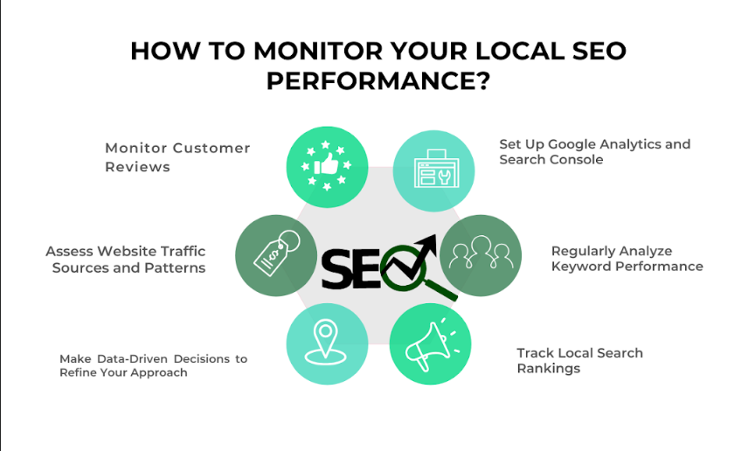

Set Up Google Analytics and Search Console:
Both Google Analytics and Google Webmaster Tools must be implemented for tracking the site’s performance. Google Analytics is used to monitor the activities of the visitors, sources of traffic, as well as conversion statistics, while Google Search Console focuses on the site performance concerning impressions and CTR.

Regularly Analyze Keyword Performance:
Keyword analysis again comes out as an ongoing activity that is performed at all times. You can use Google’s Keyword Planner that enables you to view the search volume of your chosen keywords as well as analyze the competitiveness of the keywords and changes in ranking.

Track Local Search Rankings:
It is very important to track your local search rankings to determine the status of your local SEO strategy. Using tools such as Moz Local, SEMrush and Ahrefs, you can get a more precise table on how you rank for the keywords and the locations. To ensure your business stays relevant on the local searches, frequent checks on these given rankings results.

Monitor Customer Reviews:
This makes customer reviews important in the local SEO. Perform online review monitoring using review management tools to know about the reviews on various platforms. Engage with customers to answer those negative and positive comments you receive to show how much you care about the client. It is crucial to persuade those customers to provide feedback, particularly those who are fully satisfied with the products or services you have provided to them.

Assess Website Traffic Sources and Patterns:
The initial source of website traffic and its further navigation have to be considered to improve an SEO strategy further. Use free tools like Google Analytics to analyze the traffic source, users and the conversion rates.

Make Data-Driven Decisions to Refine Your Approach:
Make it a norm to review the analytics data to enhance the next subsequent practices. These are findings that can be used to improve your content and your website, as well as your local SEO. When you are altering your keyword strategy, trying to increase your site speed or optimise your mobile usability, data is critical to success and survival in the current business environment.

Conclusion:
Local SEO is a very active area that is also constantly changing all the time and so requires constant checks. Through use of the right tools and approaches, you can ensure that you increase your online presence with the view of targeting local customers.
By adopting the above strategies, you can experience the difference in your local SEO efforts, with lots of local customers knocking on your door. When it is done methodically, your business can easily outperform your competitors. If you have any questions about how to make your local strategies more effective, you can talk to Three Angle Marketing experts (TAM). We are a team of highly professional experts who are ready to change your local business standing and help you generate more sales and conversion.

